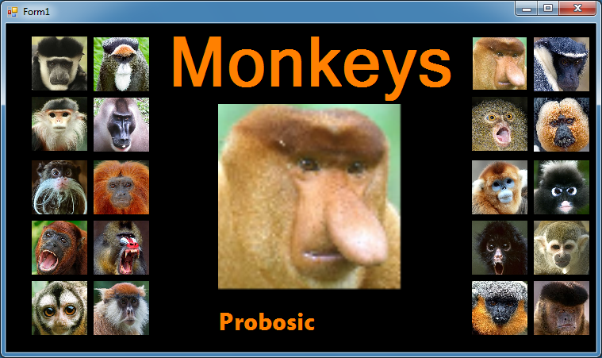

Public Class Form1

Private Sub btnColobos_Click(sender As System.Object, e As System.EventArgs) Handles btnColobos.Click

picMonkey.Image = btnColobos.Image

lblDisplay2.Text = "Colobos"

End Sub

Private Sub btnDebrazzas_Click(sender As System.Object, e As System.EventArgs) Handles btnDebrazzas.Click

picMonkey.Image = btnDebrazzas.Image

lblDisplay2.Text = "Debrazzas"

End Sub

Private Sub btnDoucLanger_Click(sender As System.Object, e As System.EventArgs) Handles btnDoucLanger.Click

picMonkey.Image = btnDoucLanger.Image

lblDisplay2.Text = "Douc Langer"

End Sub

Private Sub btnDrill_Click(sender As System.Object, e As System.EventArgs) Handles btnDrill.Click

picMonkey.Image = btnDrill.Image

lblDisplay2.Text = "Drill"

End Sub

Private Sub btnEmperorTamarin_Click(sender As System.Object, e As System.EventArgs) Handles btnEmperorTamarin.Click

picMonkey.Image = btnEmperorTamarin.Image

lblDisplay2.Text = "Emperor Tamarin"

End Sub

Private Sub btnGoldenLionTamarin_Click(sender As System.Object, e As System.EventArgs) Handles btnGoldenLionTamarin.Click

picMonkey.Image = btnGoldenLionTamarin.Image

lblDisplay2.Text = "Golden Lion Tamarin"

End Sub

Private Sub btnHowler_Click(sender As System.Object, e As System.EventArgs) Handles btnHowler.Click

picMonkey.Image = btnHowler.Image

lblDisplay2.Text = "Howler"

End Sub

Private Sub btnMandrill_Click(sender As System.Object, e As System.EventArgs) Handles btnMandrill.Click

picMonkey.Image = btnMandrill.Image

lblDisplay2.Text = "Mandrill"

End Sub

Private Sub btnOwl_Click(sender As System.Object, e As System.EventArgs) Handles btnOwl.Click

picMonkey.Image = btnOwl.Image

lblDisplay2.Text = "Owl"

End Sub

Private Sub btnPatas_Click(sender As System.Object, e As System.EventArgs) Handles btnPatas.Click

picMonkey.Image = btnPatas.Image

lblDisplay2.Text = "Patas"

End Sub

Private Sub btnProbosic_Click(sender As System.Object, e As System.EventArgs) Handles btnProbosic.Click

picMonkey.Image = btnProbosic.Image()

lblDisplay2.Text = "Probosic"

End Sub

Private Sub btnRoloway_Click(sender As System.Object, e As System.EventArgs) Handles btnRoloway.Click

picMonkey.Image = btnRoloway.Image

lblDisplay2.Text = "Roloway"

End Sub

Private Sub btnPygmy_Click(sender As System.Object, e As System.EventArgs) Handles btnPygmy.Click

picMonkey.Image = btnPygmy.Image

lblDisplay2.Text = "Pygmy"

End Sub

Private Sub btnSaki_Click(sender As System.Object, e As System.EventArgs) Handles btnSaki.Click

picMonkey.Image = btnSaki.Image

lblDisplay2.Text = "Saki"

End Sub

Private Sub btnSnubNosed_Click(sender As System.Object, e As System.EventArgs) Handles btnSnubNosed.Click

picMonkey.Image = btnSnubNosed.Image

lblDisplay2.Text = "Snub Nosed"

End Sub

Private Sub btnSpectacledLanger_Click(sender As System.Object, e As System.EventArgs) Handles btnSpectacledLanger.Click

picMonkey.Image = btnSpectacledLanger.Image

lblDisplay2.Text = "Spectacled Langer"

End Sub

Private Sub btnSpider_Click(sender As System.Object, e As System.EventArgs) Handles btnSpider.Click

picMonkey.Image = btnSpider.Image

lblDisplay2.Text = "Spider"

End Sub

Private Sub btnSquirrel_Click(sender As System.Object, e As System.EventArgs) Handles btnSquirrel.Click

picMonkey.Image = btnSquirrel.Image

lblDisplay2.Text = "Squirrel"

End Sub

Private Sub btnTiti_Click(sender As System.Object, e As System.EventArgs) Handles btnTiti.Click

picMonkey.Image = btnTiti.Image

lblDisplay2.Text = "Titi"

End Sub

Private Sub btnTuftedCapuchias_Click(sender As System.Object, e As System.EventArgs) Handles btnTuftedCapuchias.Click

picMonkey.Image = btnTuftedCapuchias.Image

lblDisplay2.Text = "Tufted Capuchias"

End Sub

End Class